Sales of products in four different regions is tabulated for males and females. Find if male-female buyer rations are similar across regions

|  |  |  |  |  |
| --- | --- | --- | --- | --- |
|  | East | West | North | South |
| Males | 50 | 142 | 131 | 70 |
| Females | 550 | 351 | 480 | 350 |

Sol.

Ho= Proportions of Male and Female are same

Ha= Proportions of Male and Female are not same

Test : **Chi-Square Test**

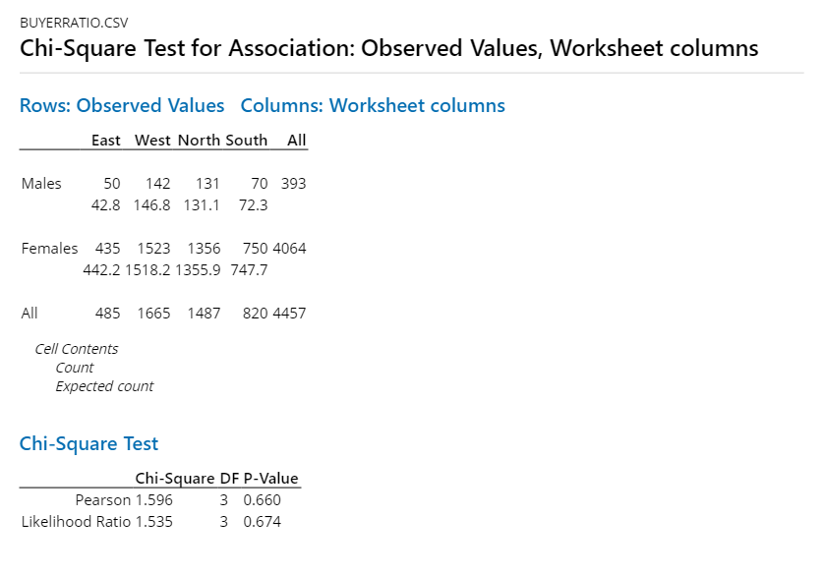

P-Value > 0.05 fail to reject null hypothesis. We will accept null hypothesis.